HR Recruitment Automation using n8n

Project Overview
This n8n automation project streamlines the HR recruitment process by automatically collecting, analysing, and filtering incoming resumes. The workflow eliminates manual screening, ensures consistent evaluation based on defined criteria, and maintains organized candidate records for easy HR review.

HR Recruitment Automation using n8n

Summary Page
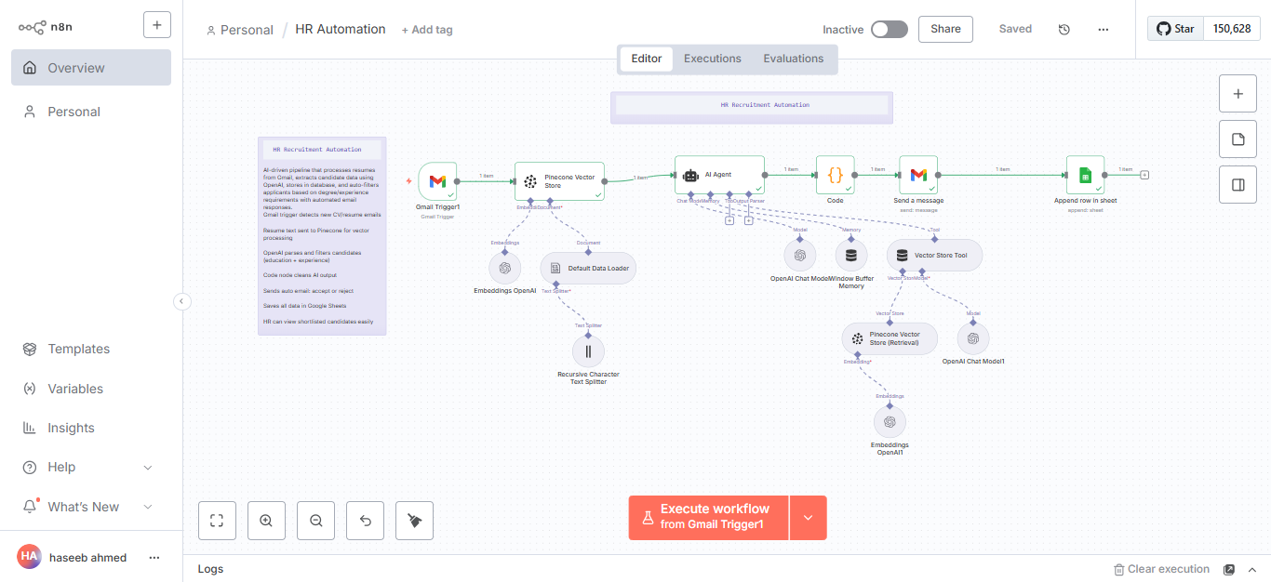

Gmail Node Monitoring
Automatically monitors the HR inbox for new emails containing attachments with the words “CV” or “Resume” in the subject or body.
Purpose: To identify and capture all incoming job applications without manual checking.
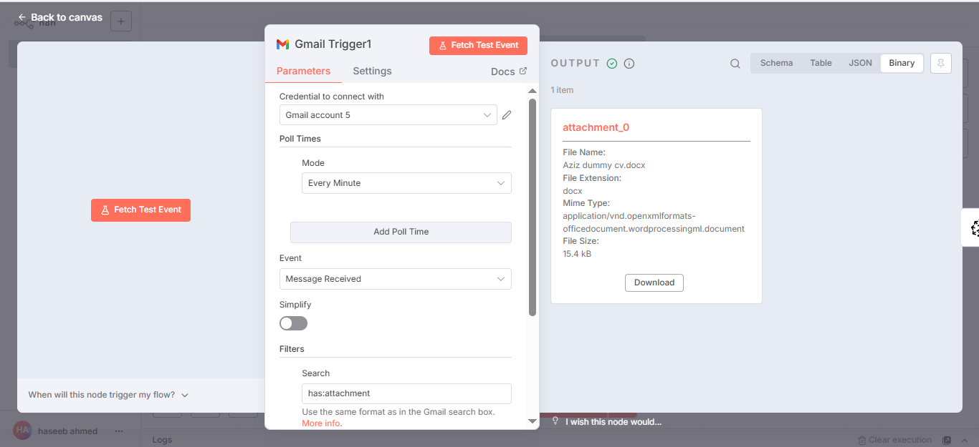

Resume Processing
When a qualifying email arrives, its attachment (resume) is sent to Pinecone Vector Store for text splitting and vectorization.
Purpose: To convert the resume text into a structured format that can be processed by AI for data extraction.
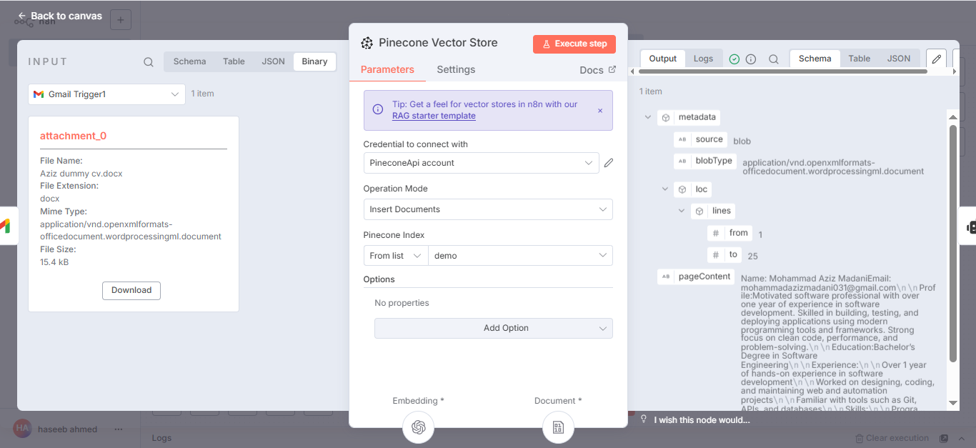

Qualification Filtering
The AI agent reviews each resume to verify qualifications:
- Education: Bachelors in Software Engineering or any Finance degree
- Experience: At least 1 year
Results:
- Application sent for further processing — qualified
- Rejected — not qualified
Purpose: Automatically filters candidates based on set criteria.
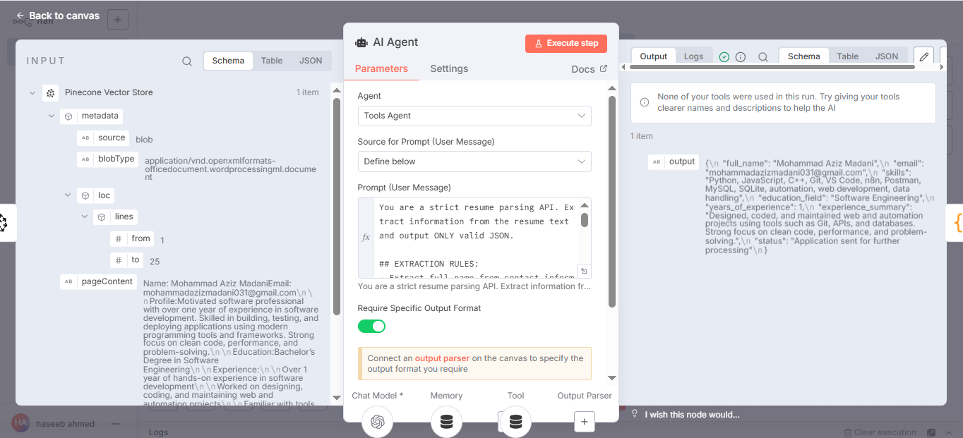

Automated Email Response
If the candidate’s resume meets company requirements, an automated email is sent to inform them that their application has been accepted and they will be contacted for an interview.
If not, a polite rejection email is sent thanking them for applying.
Purpose: To provide professional and timely communication with all candidates.
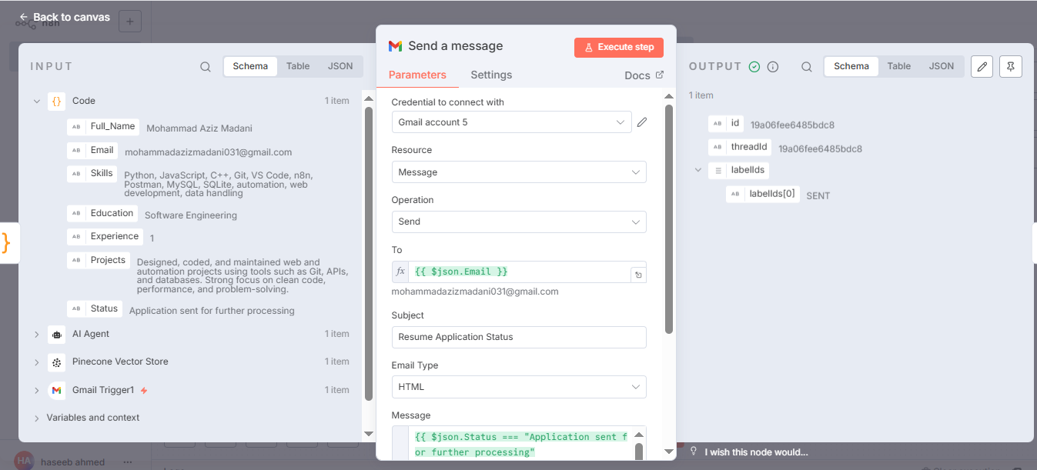

Data Logging
All candidate details, including extracted information and qualification status, are appended to a Google Sheet for HR reference.
Purpose: To maintain a centralized and organized database of all applicants for easy tracking and follow-up.
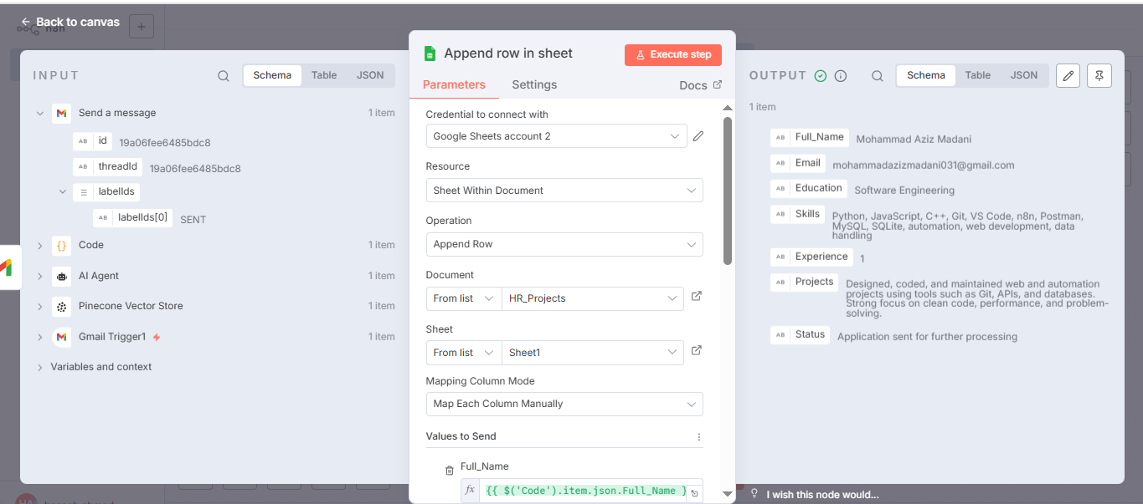

Outcome Of HR Automation Project
- Automates the complete recruitment process from email detection to candidate evaluation and response
- Saves HR time by eliminating manual screening
- Reduces human errors in resume evaluation
- Improves overall efficiency and consistency in HR operations

